YouTube Trending Videos Analysis & View Prediction

MACHINE LEARNING & DASHBOARD PROJECT

PROJECT REPORT
BY
SURAJA S
DATA ANALYST

UNDER THE GUIDANCE & SUPERVISION OF
MRS AMRITHA.MR

Palakkad, Kerala, 678702


CONTENTS

INTRODUCTION
ABSTRACT
OBJECTIVE
METHODOLOGY
DATASET OVERVIEW
DATA ANALYSIS & EDA VISUALS
MODEL DEVELOPMENT & RESULTS
DASHBOARD OERVIEW
CONCLUSION & FUTURE SCOPE

1. INTRODUCTION

The rapid expansion of digital media platforms has transformed how information and entertainment are created and consumed. Among these platforms, YouTube has emerged as one of the most influential video-sharing services worldwide, hosting millions of videos and attracting billions of users daily
YouTube’s trending feature highlights videos that experience rapid growth in engagement over a short period. However, predicting video popularity is complex, as it depends on multiple interconnected factors such as user engagement, content category, publishing time, and regional audience behavior. Traditional analytical methods often struggle to capture these relationships accurately.
Factors play a crucial role in determining a video’s performance on YouTube, including:
- Views, which indicate overall reach and popularity
- Likes and dislikes, reflecting audience response
- Comment count, representing viewer engagement
- Content category, influencing audience interest
- Publish time and trending date, affecting visibility
- Geographical region, impacting viewing patterns

2. ABSTRACT

This project focuses on analyzing YouTube trending video data and predicting video view counts using machine learning models. The dataset includes attributes such as views, likes, comments, and video metadata, which were cleaned and explored through exploratory data analysis. Several regression models were applied to predict video performance and evaluated using metrics like R², RMSE, and MAE. The results show that ensemble-based models provide better prediction accuracy, demonstrating the usefulness of machine learning for analyzing and forecasting trends in digital content platforms. A structured data science workflow is followed, which includes data preprocessing, exploratory data analysis, correlation analysis, and predictive modeling. Visualization techniques and dashboards are used to present insights clearly and support data-driven decision-making.

The primary objectives of this project are:
- To analyze YouTube trending video data and identify engagement patterns
- To determine key factors influencing video view counts
- To apply exploratory data analysis to uncover trends and correlations
- To build and compare multiple machine learning regression models
- To evaluate model performance using R² score, RMSE, and MAE
- To predict video views accurately and present insights through visual analytics

Overall, this project demonstrates the practical application of data analytics and machine learning techniques in understanding YouTube trends and predicting video popularity. The insights obtained can assist content creators and marketers in optimizing content strategies and improving audience reach through data-driven decisions.

3. OBJECTIVES

The core objectives of the project are as follows:
- To analyze YouTube trending video data and identify factors affecting video popularity
- To perform Exploratory Data Analysis (EDA) to uncover patterns and correlations
- To build and compare machine learning models for predicting video views
- To evaluate model performance using standard regression metrics
- To determine key factors influencing video view counts
- To present insights through clear visualizations and dashboards

4. METHODOLOGY

Step 1: Data Collection
- Dataset collected from social media platform YouTube

Step 2: Data Preprocessing
- Handled missing values and outliers.
- Removal of duplicate records
- Conversion of date and time fields into usable formats
- Feature selection for model training

Step 3: Exploratory Data Analysis (EDA)

Statistical analysis of views, likes, comments, and dislikes

Correlation analysis using heatmaps

Country-wise and day-wise engagement analysis

Visualization of trends and distributions

Step 4: Model Building
- Implemented machine learning models:
- Linear Regression
- Random Forest Regressor
- Decision Tree
- Ridge Regressor
- Gradient Boosting Regressor
- XGBoost Regressor
Hyperparameter tuning performed using GridSearchCV.

Step 5: Dashboard Development
- Developed an interactive dashboard using Power BI to visualize engagement trends and performance metrics.

5. DATASET OVERVIEW

- Source: YouTube trending dataset
- Platform: Youtube
- Key Features:
  - title
  - channel title
  - category id
  - publish date
  - time frame
  - published day of week
  - published country
  - tags
  - views
  - likes
  - dislikes
  - comment count
  - comment disabled
  - rating disabled
  - video error or video removed
- Target Variable: Views
The dataset supports supervised machine learning and provides valuable insights into audience interaction behavior.

6. DATA ANALYSIS & EDA VISUALS

Key Observations:

Videos with higher likes and comments consistently achieve higher view counts

Views show a strong positive correlation with likes and comment count

Engagement levels vary significantly across countries, with Great Britain and the United States leading

Friday records the highest engagement, making it the most effective day for publishing content

Tree-based models outperform linear models due to their ability to handle non-linear relationships

Visualizations Used:
- Bar plots
- Line charts
- Engagement plots
- Scatter plots
- Correlation heatmaps
EDA helped guide feature selection and improve model performance.

7. MODEL DEVELOPMENT & RESULTS

Models Applied:
- Linear Regression
- Ridge regression
- Decision Tree regressor
- Random Forest regressor
- XG Boosting
- Gradient boosting

Best Model: Random Forest Regressor
- Achieved the highest accuracy and lowest error.
- Effectively captured non-linear relationships between features.

8. DASHBOARD OVERVIEW

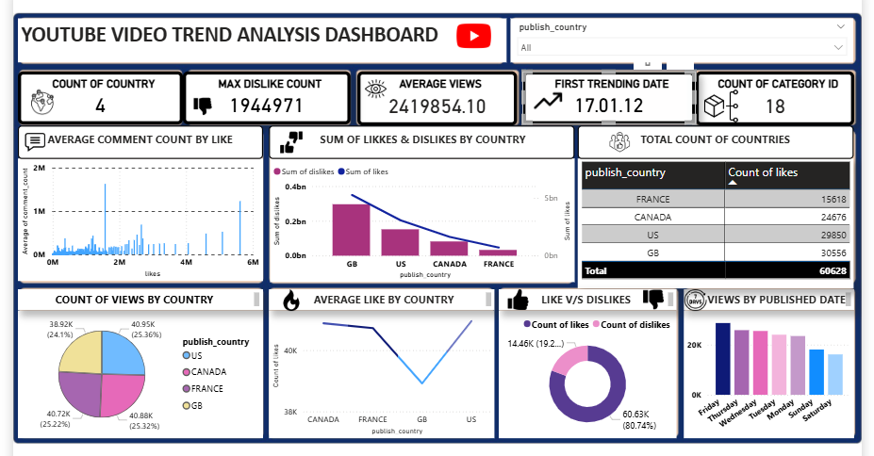

The interactive dashboard presents key engagement insights, including:
- Total engagement by platform
- Likes and comments by post type
- Engagement trends over time
- Sentiment-based performance analysis
Interactive filters allow users to explore specific platforms, post types, and posting times.

9. CONCLUSION & FUTURE SCOPE

Conclusion:

This project successfully demonstrates how data analysis and machine learning can be used to understand and predict YouTube video popularity. Engagement metrics such as likes and comments play a crucial role in driving views. Among the models evaluated, tree-based algorithms—particularly Random Forest and XGBoost—delivered the best predictive performance. The integration of machine learning with visual dashboards provides actionable insights for optimizing content strategy and improving reach.

Future Scope:

- Perform sentiment analysis on video titles and comments
- Analyze thumbnail images using computer vision techniques
- Integrate real-time data using the YouTube API
- Apply deep learning models for improved prediction accuracy
- Develop a recommendation system for content creators

Thank You

